**CloudWatch:**

Amazon CloudWatch monitors your Amazon Web Services (AWS) resources and the applications you run on AWS in real time. You can use CloudWatch to collect and track metrics, which are variables you can measure for your resources and applications.

Ref: <https://docs.aws.amazon.com/AmazonCloudWatch/latest/monitoring/WhatIsCloudWatch.html>

**Task: 1**

**Create a dashboard which lets you check the CPU utilization and networking for a particular EC2 instance**

**Launch instance:**

* To get started, launch an Amazon EC2 instance, which is a virtual server in the cloud**.**

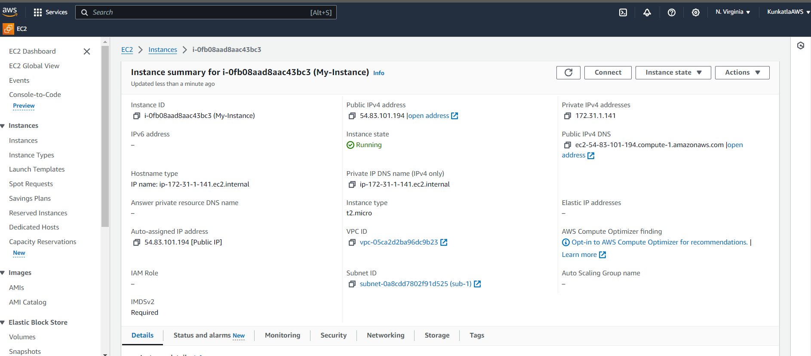

**Create 'cloudwatch’- Custom-dashboard:**

* Search results for 'cloudwatch’ service in aws console
* Goto dashboard
* Create custom dashboard
* Here Add widget
* Widget Configuration
* Select datatype (metrics/logs/alarms) and
* Widget Type (Line/Number/stacked area/pie/data table/Gauge/Bar/Explorer)
* Search for any metrics
* Search EC2 🡪 Click Per-Instance Metrics 🡪 Search your instance Id here [i-0fb08aad8aac43bc3](https://us-east-1.console.aws.amazon.com/ec2/home?region=us-east-1#InstanceDetails:instanceId=i-0fb08aad8aac43bc3)
* Select Correct Instance and Metrics Type **(CPUUtilization)**

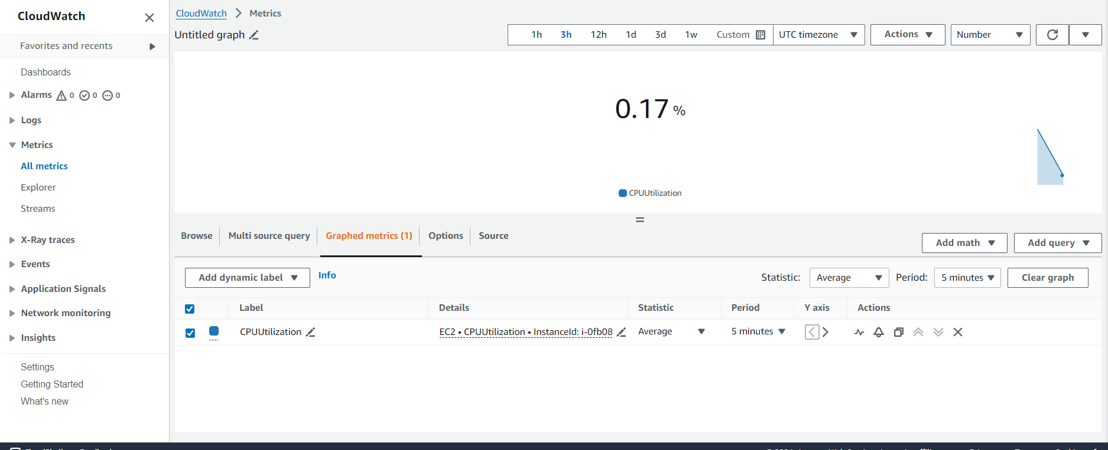

**Dashboard-Networking for a particular EC2 instance:**

* Configure Dashboard with Network In; Network Out; Status Check Failed

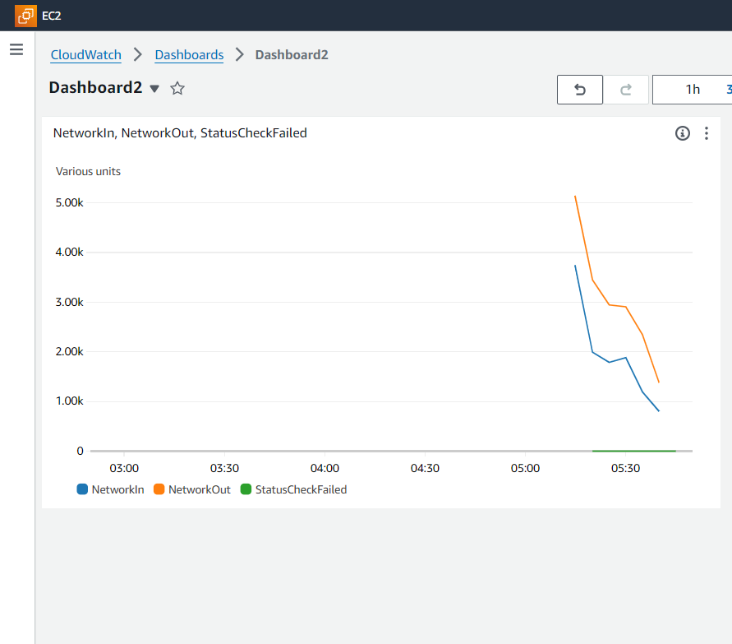

**Task -2 :**

1. **Create a CloudWatch billing alarm which goes off when the estimated charges go above $500**

**Create Billing** ⏰ **Alaram** 🔔 **:**

**🡪 Specify metric and conditions**

* + - **Select Metric and click next**
    - Metric name 🡪 Currency 🡪 Statistic 🡪 Period
    - 🡪 Threshold type 🡪 Whenever Estimated Charges
    - 🡪 Define the threshold value
    - Click Next

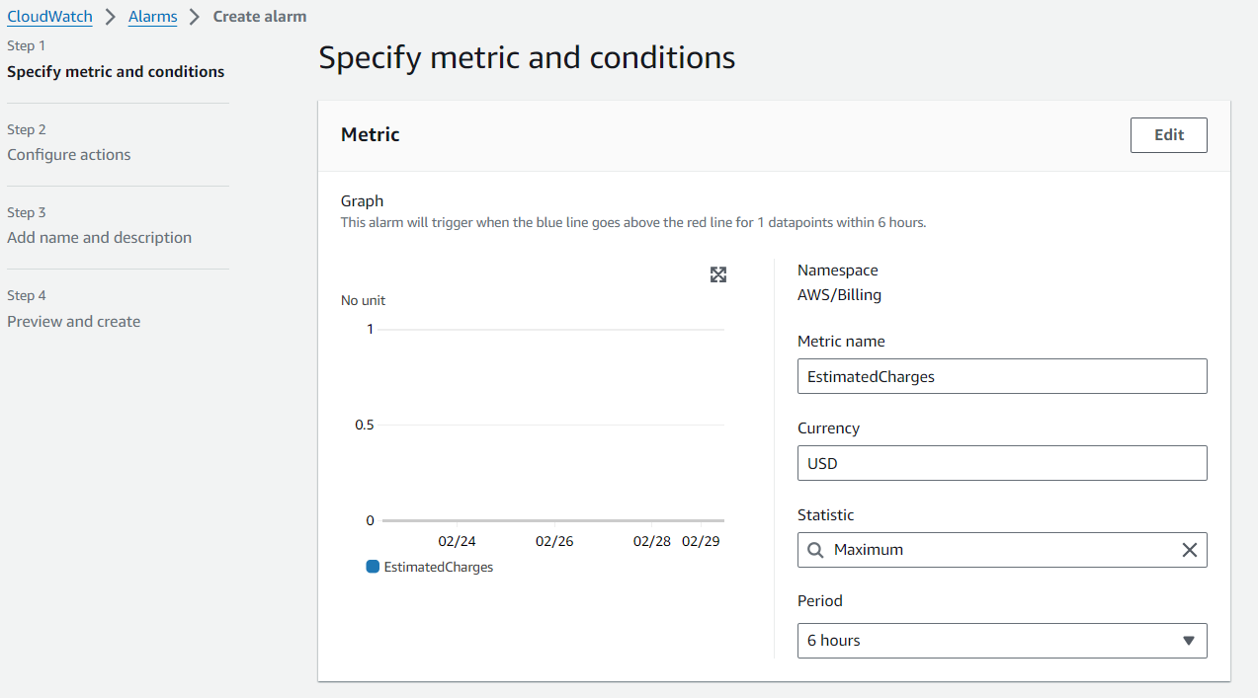

**Configure actions:**

Alarm state trigger 🡪 Send a notification to the following SNS topic 🡪 Create a new topic… 🡪 Email endpoints that will receive the notification…

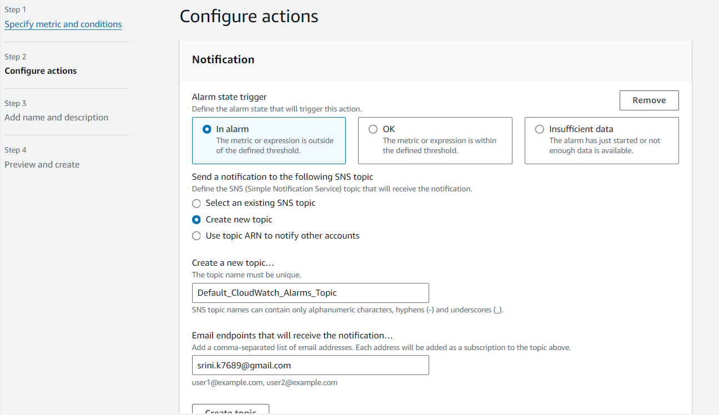

Next

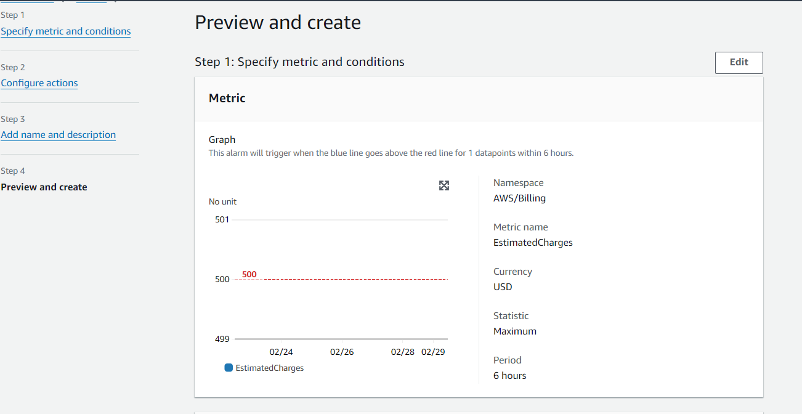

next

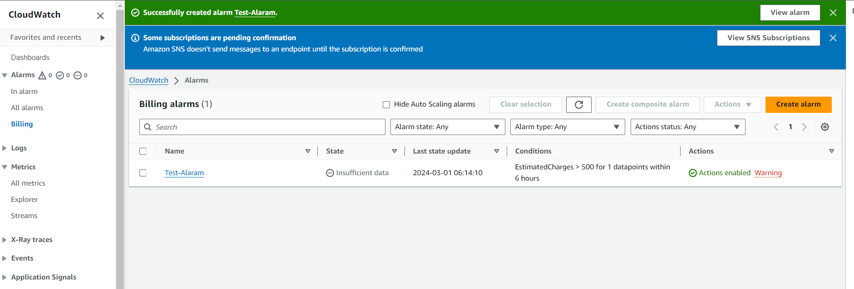

Email-Notification received



